Name: Varia Neel Jitesh
Enrollment No: 250447003019

Network Security And Forensics
Lab Session – 3
Perform the depth protocol analysis by Wireshark.
Set up Wireshark to capture packets on a network interface.
- Capture and analyze various types of traffic, such as HTTP, DNS, and FTP.
- Examine packet headers, source and destination IP addresses, port numbers, and protocols.

- Use display filters to focus on specific types of traffic
- Experiment with different display filter expressions.
- Explore and understand color-coded packet markings.

- Analyses the handshake process in
- Investigate DNS query and response packets.
- Examine HTTP requests and responses, including headers and content. Packet Filtering and Display Filters:
- Use Wireshark to capture network traffic in a specific scenario (e.g., browsing a website, downloading a file).
- Apply display filters in Wireshark to isolate specific types of packets (e.g., HTTP, TCP).
- Experiment with different display filters and observe how they affect the captured traffic view.
- How can display filters help in focusing on relevant packets during network analysis?

Capture and analyze various types of traffic, such as HTTP, DNS, and FTP.
HTTP Packets
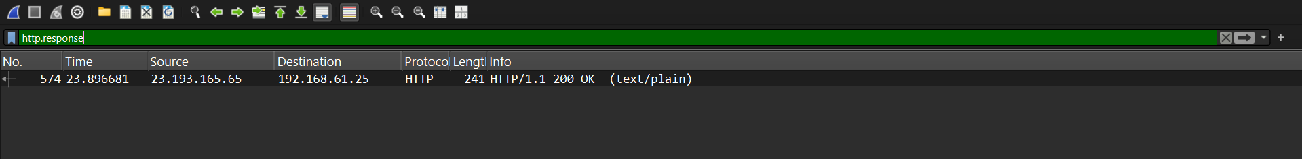

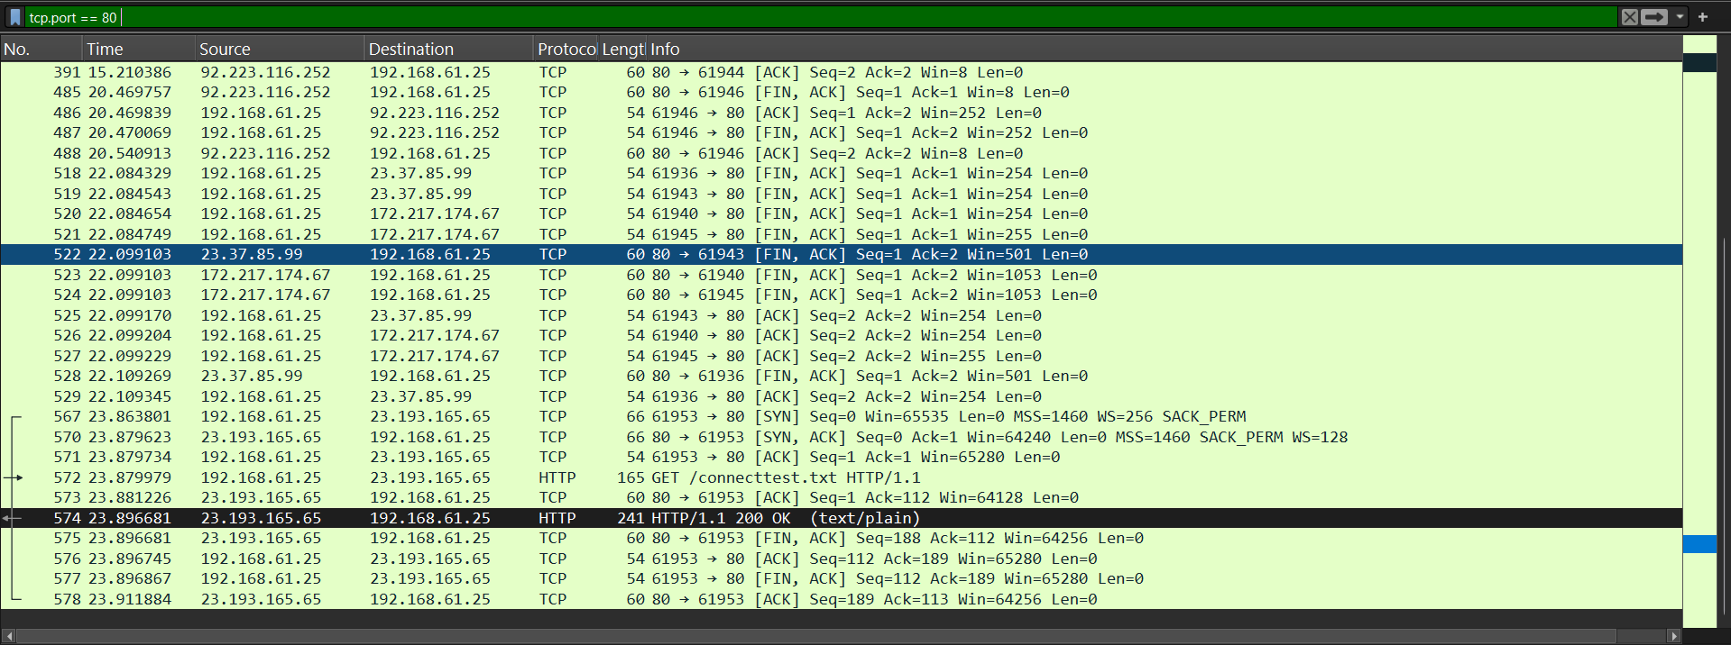
DNS

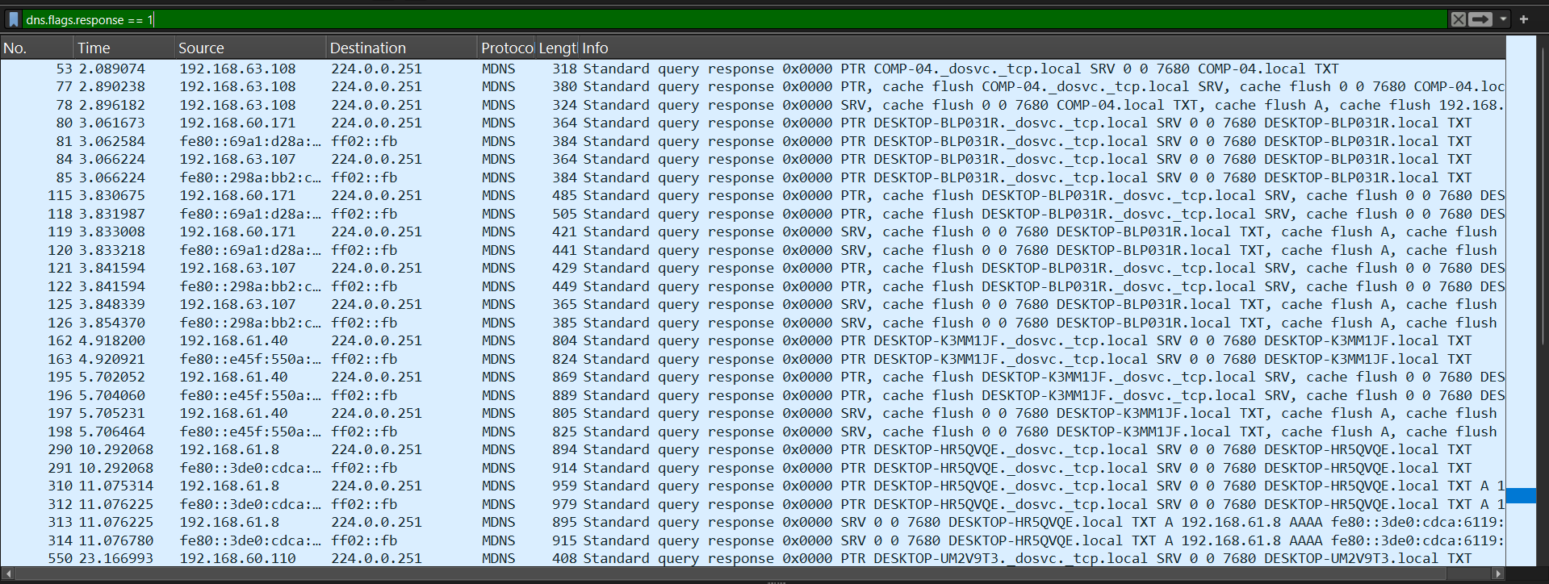

Layer | Header Type | Purpose
Layer 2 | Ethernet Header | MAC addressing
Layer 3 | IP Header | Logical addressing
Layer 4 | TCP / UDP Header | Port numbers, reliability
Layer 7 | Application Header | Protocol-specific data

Packet Headers
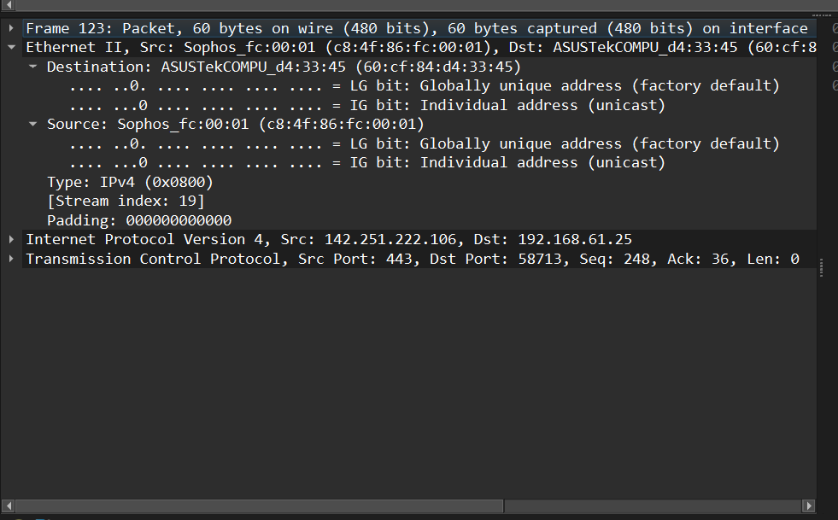

Examining IP Header
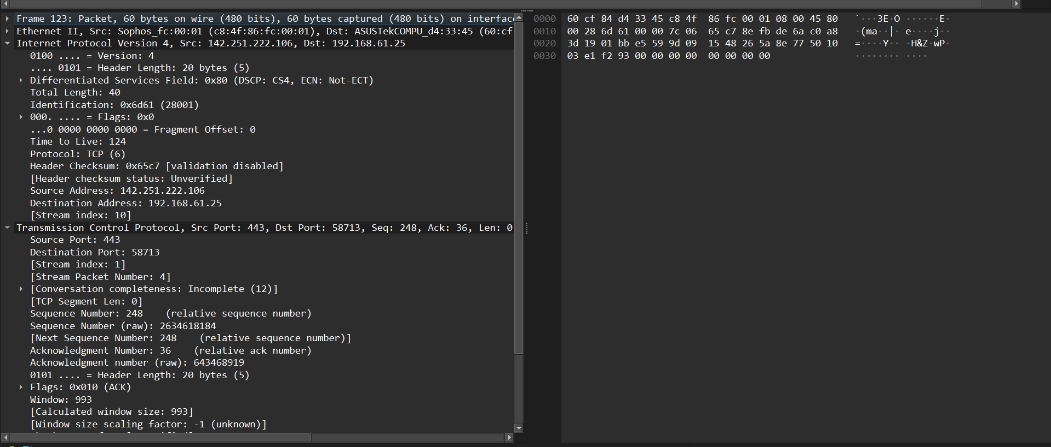

Examining Application Layer Protocols
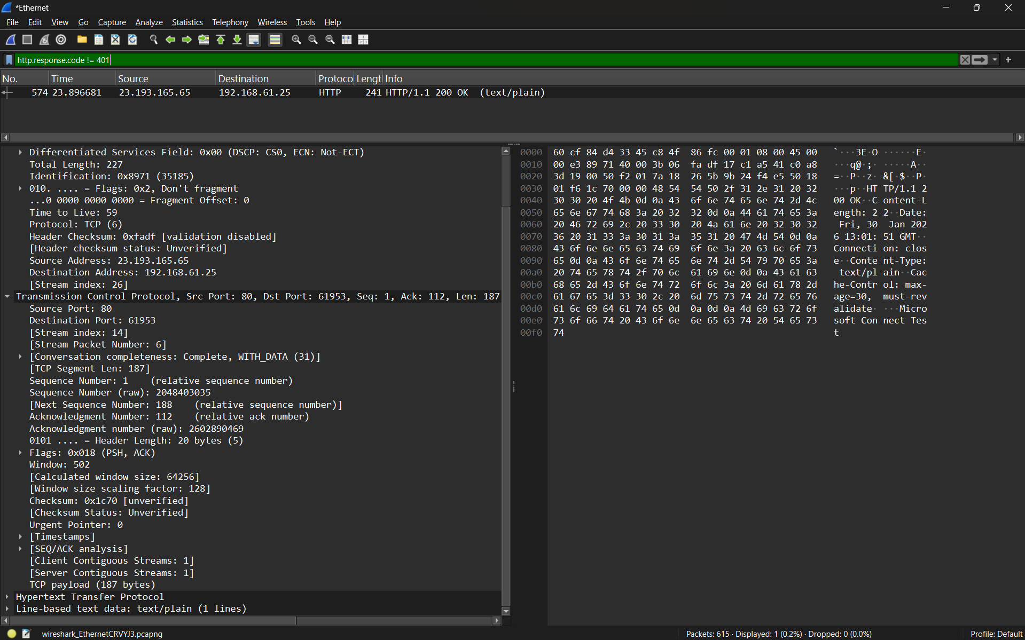

Use display filters to focus on specific types of traffic
Specific HTTP Filters
http.request
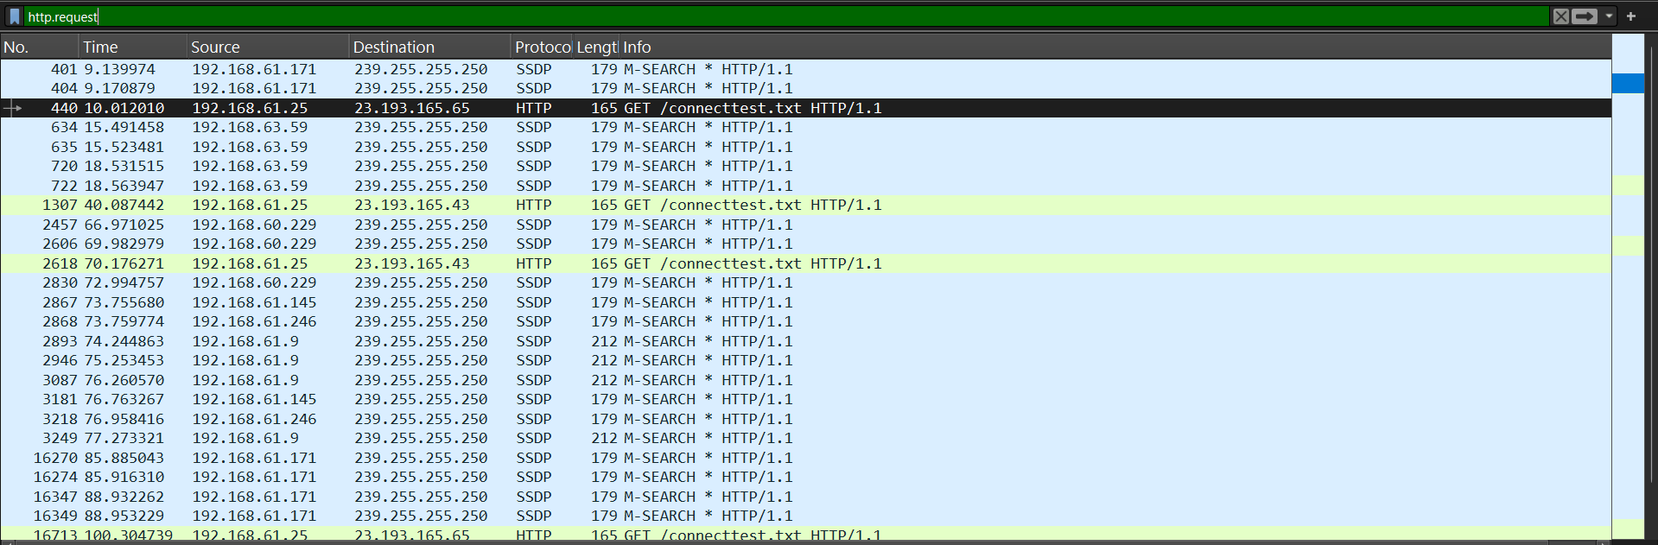

http.response
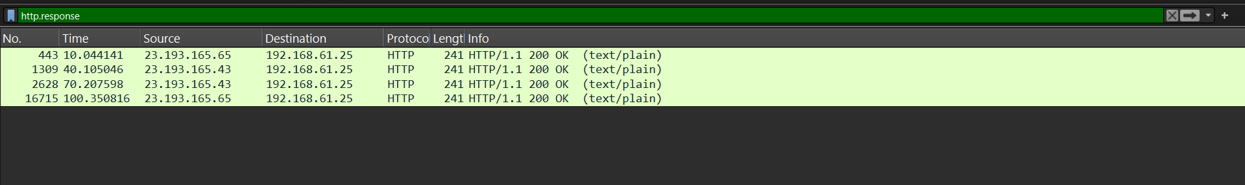

http.request.method == "GET"
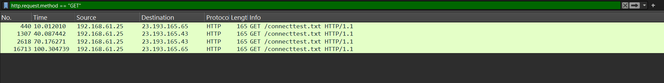
tcp.port == 80
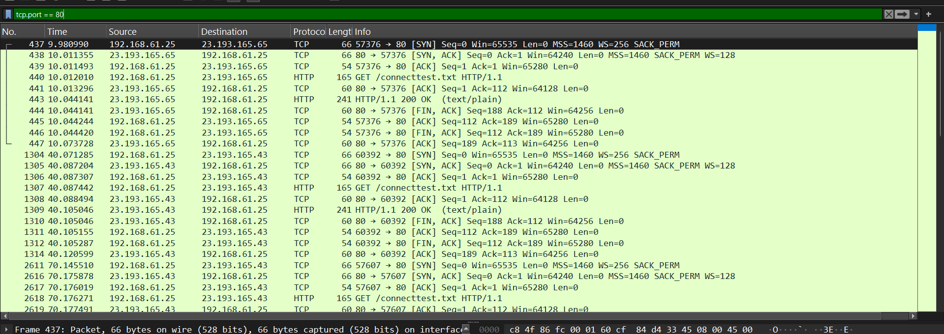
Used to analyze web browsing activity.

udp.port == 53
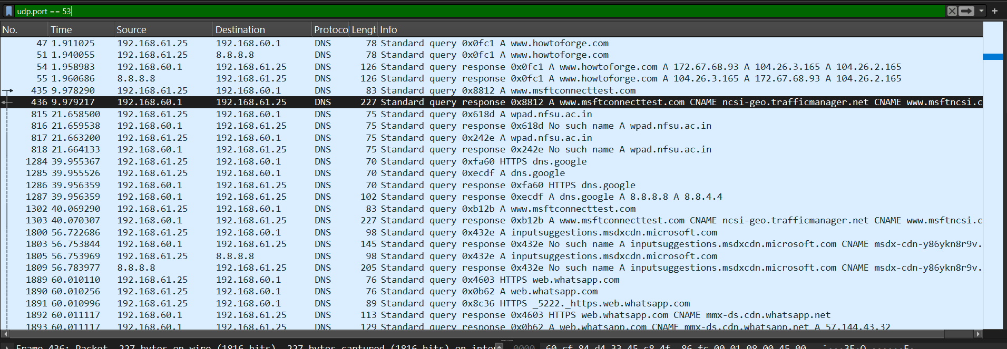
dns.qry.name
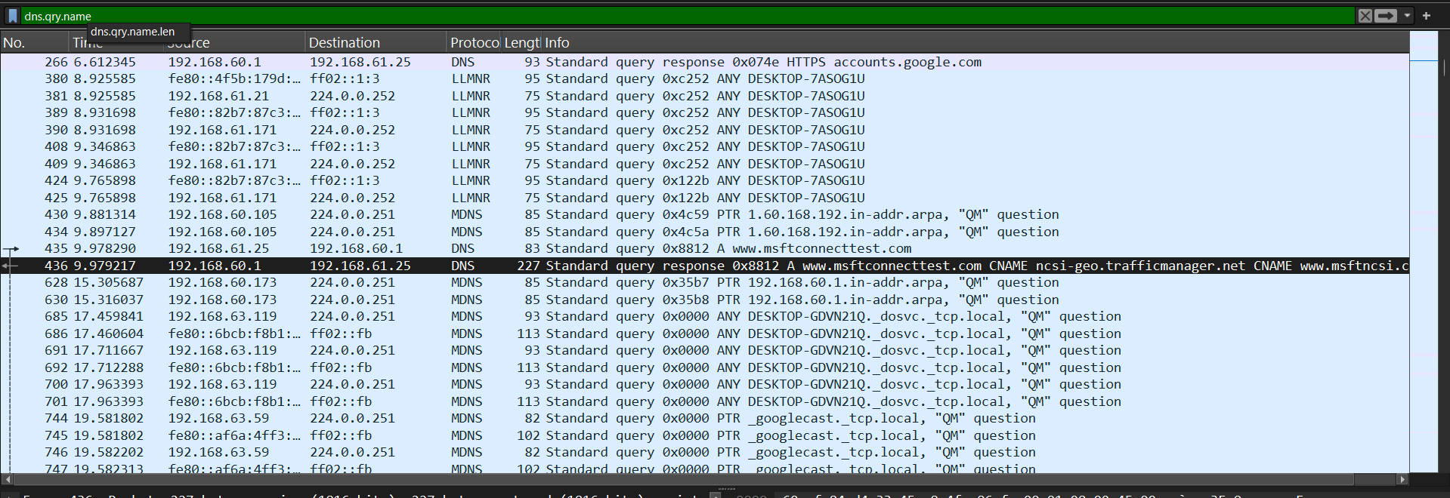
dns.flags.response == 1
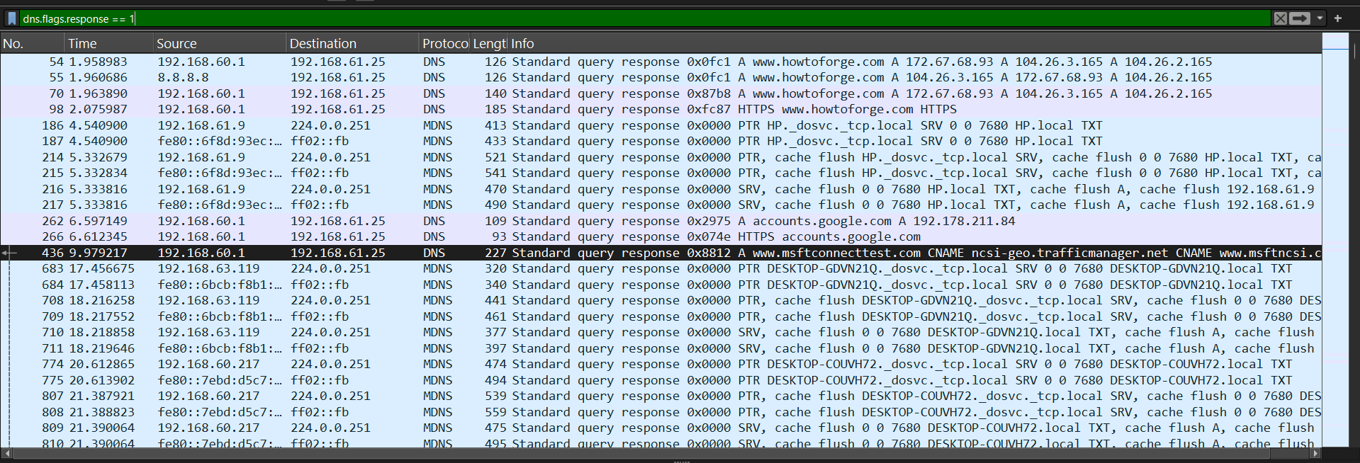

dns && dns.flags.response == 0
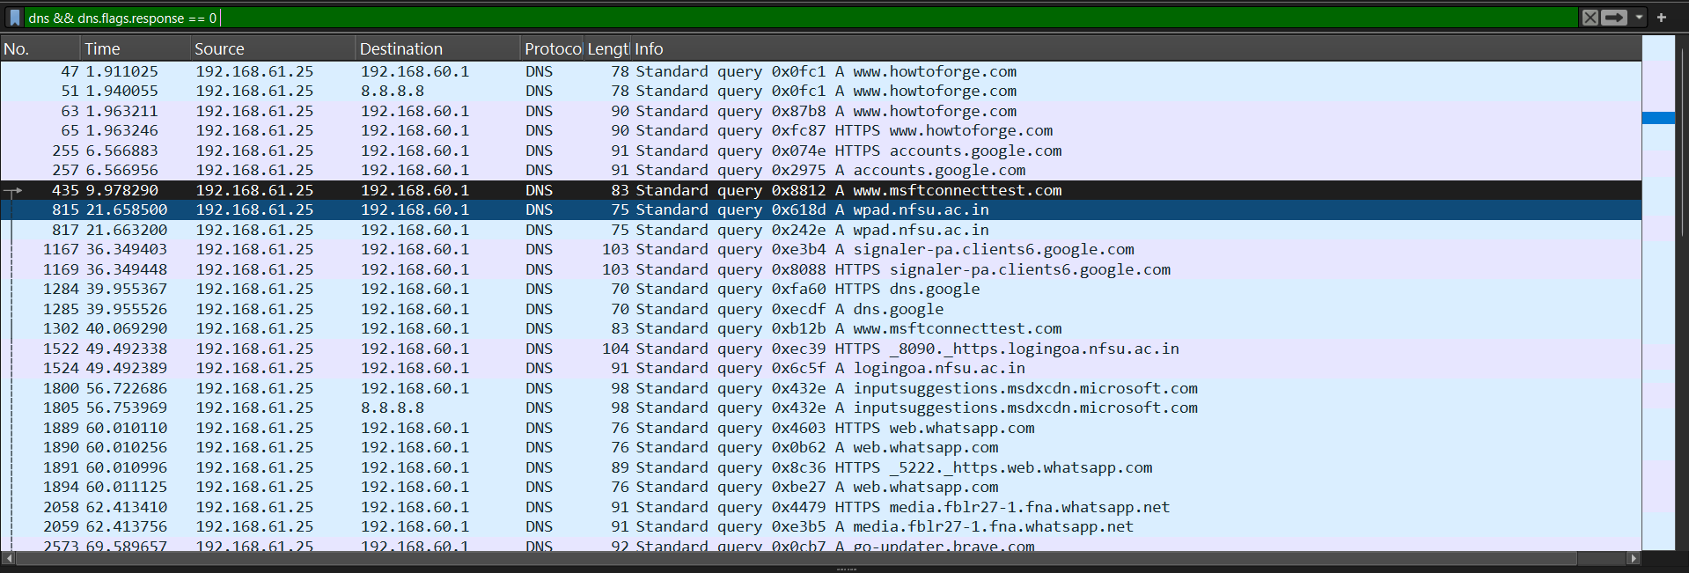

Explore and understand color-coded packet markings.
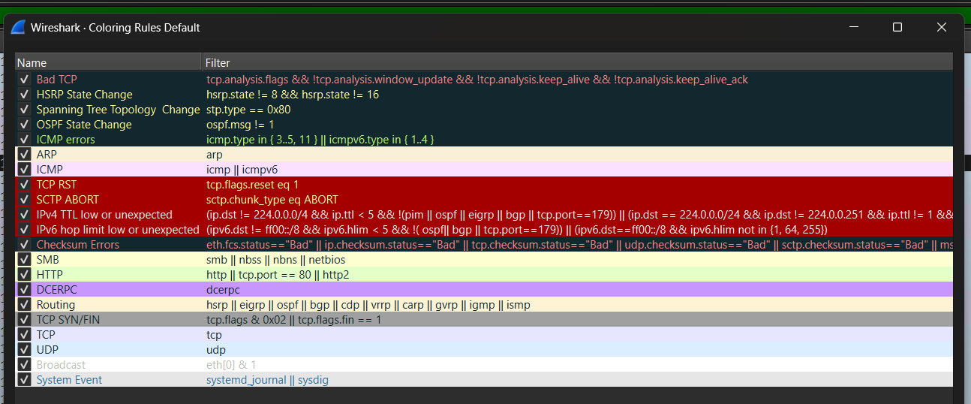

Analyze the handshake process in Wireshark
The TCP three-way handshake is the process used by the Transmission Control Protocol (TCP) to establish a reliable connection between a client and a server before data transfer begins.

Filtering Only Handshake Packets

SYN (Synchronize)
SYN-ACK (Synchronize + Acknowledge)
ACK (Acknowledge)

Only SYN Packets
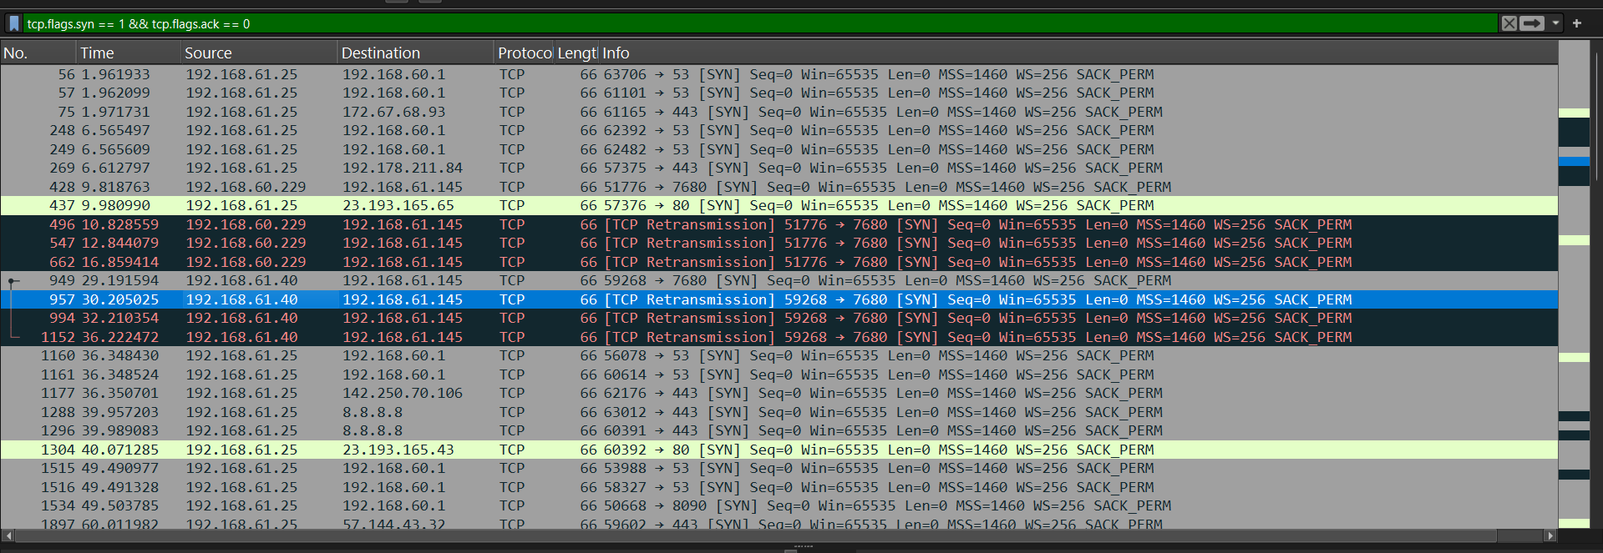

SYN-ACK Packets
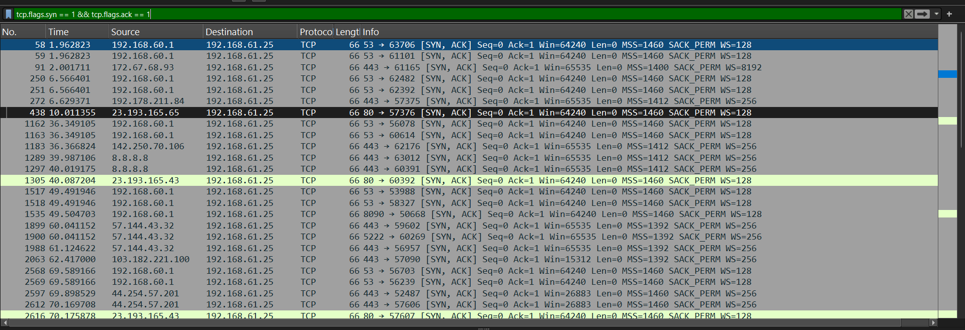
ACK Packets
